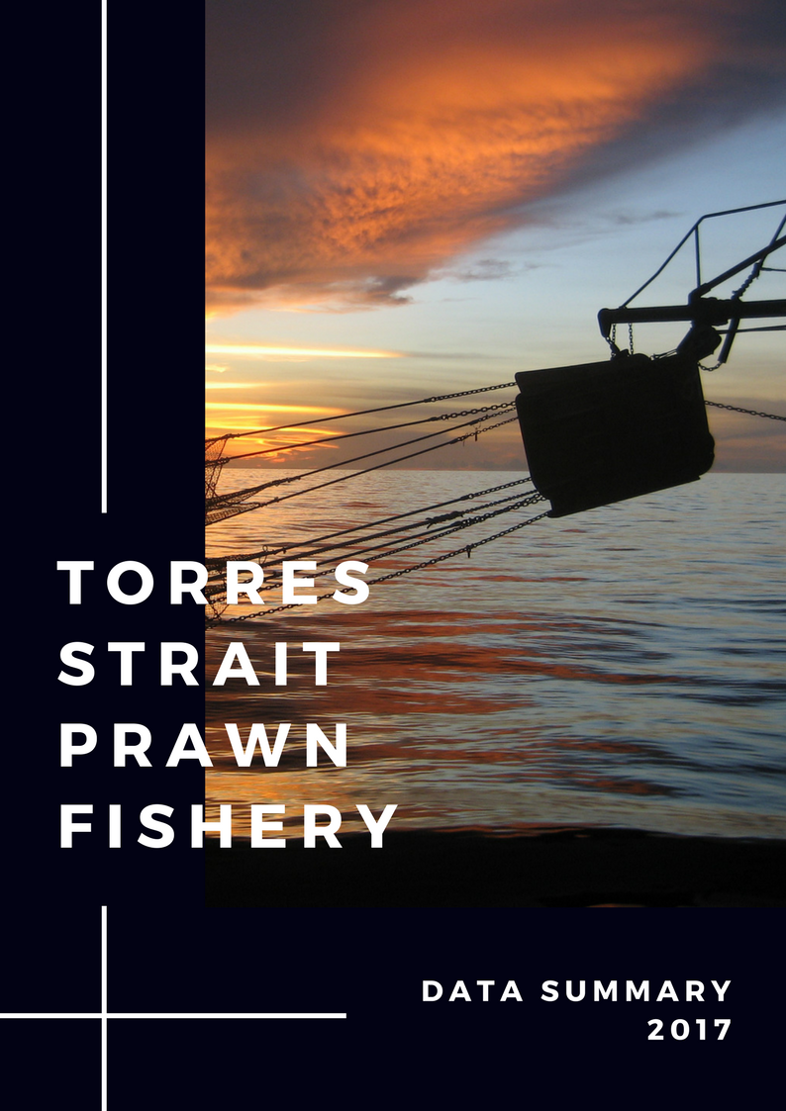

**Torres Strait Prawn Fishery Data Summary 2017**

**COPIES AVAILABLE FROM:**

Australian Fisheries Management Authority

Box 7051, Canberra Business Centre,

Canberra, ACT 2601 Australia.

**OR**

Electronically on the [Torres Strait Protected Zone Joint Authority website](http://pzja.gov.au/the-fisheries/torres-strait-prawn-fishery/).

**Preferred way to cite this publication:**

Turnbull, C., Cocking, Lisa (2018), *Torres Strait Prawn Fishery Data Summary 2017*, Australian Fisheries Management Authority. Canberra, Australia.

**© Commonwealth of Australia 2018**

This work is copyright. Apart from any use as permitted under the Copyright Act 1968, no part may be reproduced by any process without prior written permission from the Commonwealth available from AusInfo. Requests and inquiries concerning reproduction and rights should be addressed to the Manager, Legislative Service, AusInfo, GPO Box 1920, Canberra ACT 2601

## Torres Strait Prawn Fishery Data Summary 2017

If you have any comments or questions relating to this document please contact

Lisa Cocking

Senior Management Officer

Torres Strait Prawn Fishery

AFMA Phone: (02) 6225 5451

Email: [lisa.cocking@afma.gov.au](mailto:lisa.cocking@afma.gov.au)

Also note that this Data Summary is available on the [PZJA website](http://www.pzja.gov.au).

**Contents**

Torres Strait Prawn Fishery Data Summary 2017 3

Introduction 5

Description of the Torres Strait Prawn Fishery 6

Data Collection Program 7

Methods Used For Preparing Data Summary 7

Catch and Effort Data for the Torres Strait Prawn Fishery 8

Total fishing days in the area of the fishery 8

Catch and effort by year 9

Fishing catch rates and stock biomass 14

Spatial distribution of fishing effort and catches 16

Monthly trends in Fishing Effort 19

Monthly trends in CPUE 20

Summary 22

Appendix 1 - Details by month of catches and effort since 1989 23

Moon Calendar inside back cover

## Introduction

This document summarises catch and effort information for the Torres Strait Prawn Fishery (TSPF) from the 2017 fishing season in comparison to previous years. The data summary is a valuable tool for providing feedback to stakeholders on logbook data received by AFMA. It is also used by the Torres Strait Prawn Management Advisory Committee in guiding management recommendations and discussions. The data summary is sent to license holders annually but is available to all stakeholders via the PZJA website (www.pzja.gov.au).

Thank you to the cooperative trawler skippers for submitting their logbook information, an essential record of catches and effort for the fishery has been built up over many years. This “time-series” of data spans 40 years (1978 to present) and is used to monitor trends in fishing effort, catches and catch rates by area (spatial trends), time (temporal trends) and species. A long time-series with wide variations in fishing effort and catches is needed for stock models. These models are used to estimate the level of fishing effort and catch that will ensure sustainability of the harvest while maximising the productivity of the fishery.

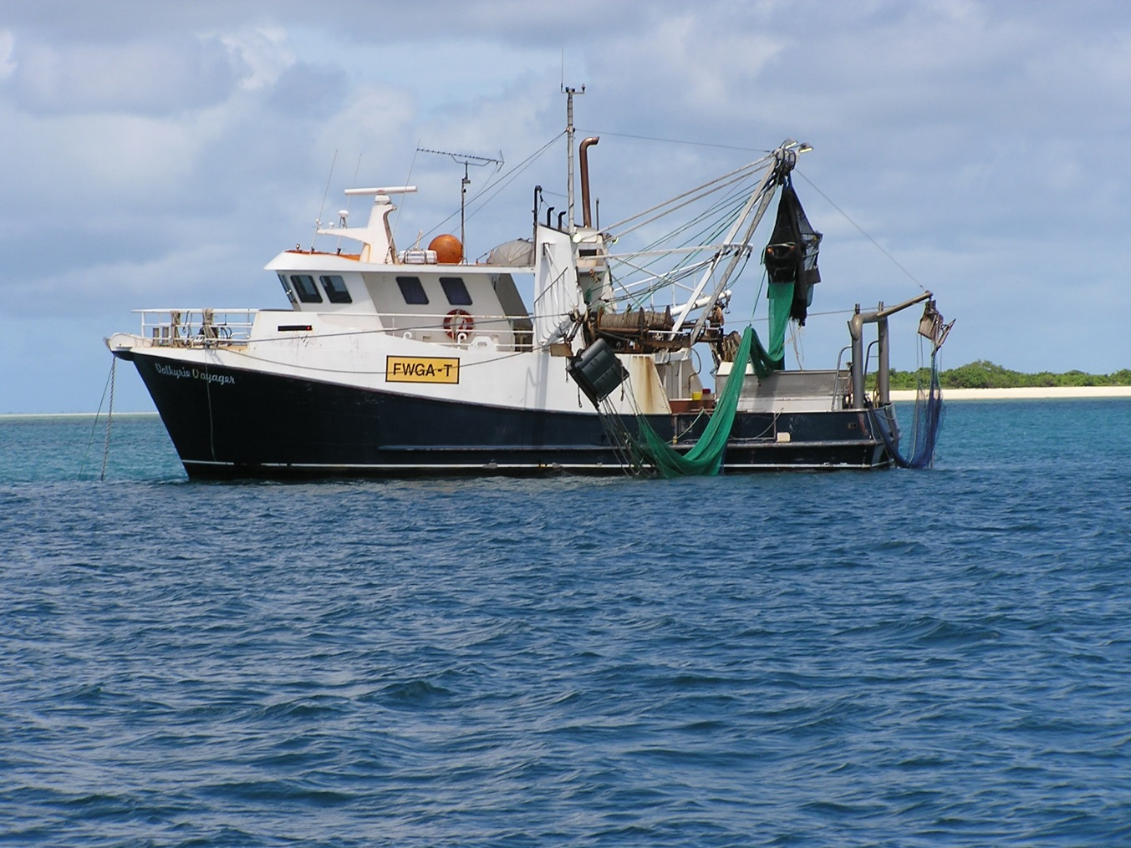

## Description of the Torres Strait Prawn Fishery

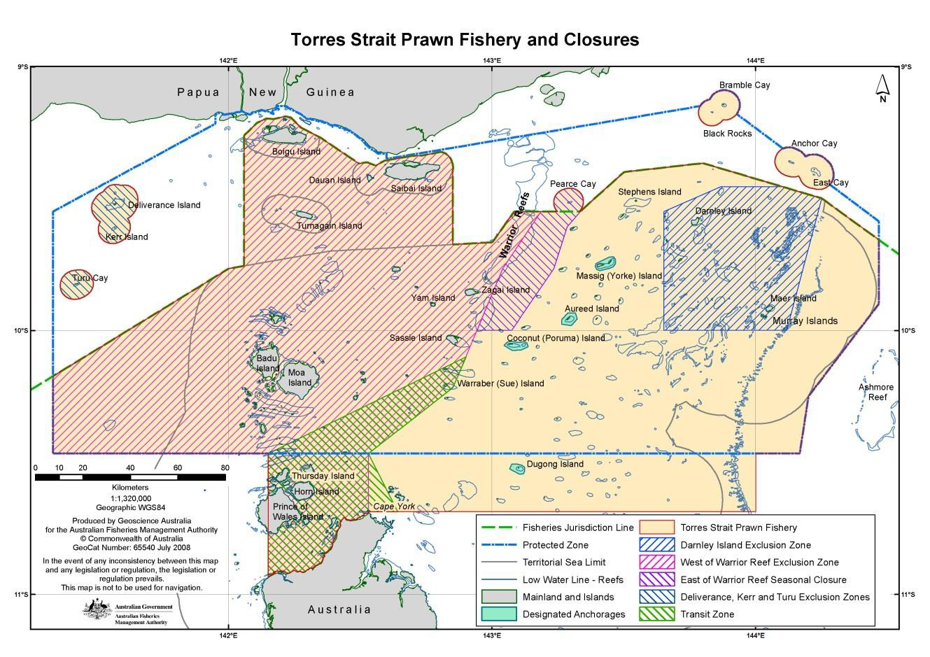

The TSPF is a multi-species prawn fishery which operates in the eastern part of the Torres Strait. Brown tiger prawns (*Penaeus esculentus*) and blue endeavour prawns (*Metapenaeus endeavouri*) are the key target species. Red spot king prawns (*Melicertus longistylus*), Moreton Bay bugs (*Thenus spp.*), scallops (*Amusium* spp.), slipper and shovel-nosed lobster (*Scyllaridae*) and squid (*Teuthooidea*) are taken as by-product.

Fishing is permitted in the TSPF from 1 February to 1 December each year and is limited by a Total Allowable Effort (TAE) in the form of fishing days. Individual fishers receive an annual use entitlement which is converted based on the TAE and the number of units of fishing capacity (UFC) they hold. Fishing for prawns in the TSPF occurs at night, primarily using the otter trawl method which involves towing two, three or four trawl nets behind a vessel. However effort is referred to as fishing days due definitions in the legislation. The TSPF has restrictions on the quantity of net (governed by head and footrope length) and length of vessel that can be used to operate in the fishery.

For detailed information on the management of the TSPF you can download the TSPF Handbook from the PZJA website (www.pzja.gov.au).

## Data Collection Program

**Logbooks**

The PZJA collect data for the TSPF through both operator completed daily fishing logbooks and an automatic Vessel Monitoring System (VMS). The VMS is a satellite monitoring system which collects information on boat locations. A boat is recorded to be fishing if it moves more than 250m at any time between 1800 local time on that day and 0600 on the next day, isn’t within a designated anchorage or if a boats VMS system is failing to poll.

VMS was introduced in 2005 and is mandatory on all boats in the TSPF. All TSPF operators are also required to complete a daily fishing logbook, which collects information on the boat, gear, area fishing and catch. The logbooks are available in electronic form, and are the simplest way to submit logbooks, avoiding the need to carry and order paper logbooks and manually submit logbooks which can sometimes be difficult to do at sea. Alternatively operators can complete the ‘Northern and Torres Strait Prawn Fisheries Daily Fishing Log’ (NP16), a paper logbook on a daily basis (see Torres Strait Fisheries Logbook Instrument 2015). Both paper logbook and e–log data are included in this data summary.

Because logbooks have only been compulsory In the TSPF since 1989, the total catch prior to 1989 was estimated from unload records. The voluntary logbook records from some operators provided the catch rate information.

In 1993 each license holder was allocated “days of fishing access” which reduced the allowable effort in the fishery greatly. The allocation was based on their prior history of fishing in the TSPF and a manual reporting system was introduce to track the number of days that each vessel was within the Torres Strait Zone and hence deemed as fishing.

### Methods Used For Preparing Data Summary

The data used to prepare this summary is comprised of logbook information (NP16 and e‐log) and Vessel Monitoring System data (VMS) data. VMS data is collected using satellite transceivers which can record the area fished and fishing speed, allowing AFMA to deduct days fished and monitor closed areas. This data is stored by AFMA.

The data used in this summary was extracted during late December 2017. All logbook sheets for the 2017 season had been submitted by fishers at this time. The data is checked using species and fishing positions constraints to identify any records that have been incorrectly assigned to the TSPF. These records are filtered out and returned to the AFMA data section for checking and correction.

Plots of fishing effort post 1988 are based on the number of daily vessel logbook records (days fished) and the VMS. Prior to 1989 the “days fished” and catches are estimated from voluntary logbook records and unload records. The “VMS” days fished are slightly higher than the logbook “days fished” because vessels are automatically flagged as fishing when steaming at trawl speed or if the VMS unit fails to poll. Fishers can claim back these fishing days if they verify that they were not fishing but often do not if it is near the end of the season and they still have unused days.

## Catch and Effort Data for the Torres Strait Prawn Fishery

### Total fishing days in the area of the fishery

The total fishing days in the area of the Torres Strait Prawn Fishery (TSPF) from 1993 - 2017 are plotted in Figure 1. Aside from a slight increase in 2012, 2015 and 2016, effort has been declining since 1999. The total percentage of days used in 2017 was only 15% of the of the allowable Australian proportion of the effort (6,867 days), detailed in Figure 2.



Year

Fishing Effort (d)

25

10

26

25

19

17

10

9

13

14

12

14

9

6

**Figure 1.** Total days fished in the Torres Strait Prawn Fishery for the years 1993‑2017. The numbers above the bars are the total days fished, and the red numbers inside the bars are the number of active boats across the whole season. Figure displays manually reported fishing days for the years 1993-2004, and vessel monitoring system fishing day records for 2005-2017.

**Figure 2.** Proportion of the total TSPF Australian allocation (total of 6,867) of fishing days fished in the 2017 season.

### Catch and effort by year

As fishing effort increased during the developmental years of the fishery 1978-1991, the endeavour prawn catch increased (Figure 3), then as the effort dropped during 2001–2011, so did the endeavour prawn catch. In contrast the tiger prawn catch has been relatively stable although higher during the years of highest effort (1991-2001). Therefore the trend in the overall prawn catch is mainly a result of changes in the endeavour catch.

**Figure 3.** Total annual catch (tonnes) of tiger, endeavour, king and mixed prawns and total annual fishing effort (days) for both logbook records and Vessel Monitoring System (VMS) days fished. Note that “logbook data” for 1978 to 1988 was through voluntary unload logbooks. In 1989 mandatory logbooks were introduced resulting in more complete data.

**Figure 4.** The percentage species composition for tiger, endeavour, king and mixed prawns of the total prawn harvest by weight from 1978 - 2016. The Figure also includes the total annual fishing effort measured through logbook days.

The species catch composition since 2009 (Figure 4) has been similar to the early fishery years. During the period when fishing effort was highest the percentage of endeavour prawn was also highest (48-60%). Post 2011 fishing effort stabilised at around 2,000 days and tiger prawn has comprised more than 70% of the catch. The 2016 season had the highest percentage of tiger prawn (85%) since 1978.

During the years 2001 to 2007 the tiger prawn catch remained close to the long term average despite the large decrease in fishing effort whereas endeavour prawn catch tracked downward, mirroring the decrease in effort. After 2007 the catch of both tiger and endeavour prawn tracked downward and reached their lowest points in 2011 when fishing effort was at its lowest.

Changes in the species composition of the harvest result from variability in the annual recruitment and changes in the landed value of each species. The landed prices influence which species are targeted by fishers. Recruitment, which is effected by the level of fishing effort, determines the abundance of each species on the sea bed. The period of highest fishing effort (1990s) matches the time of highest endeavour prawn abundance and lowest tiger abundance, as indicated by Catch Per Unit of Effort (CPUE; Table 1, Figures 5 & 6).

It was hypothesized that the decline in fishing effort after 2001 was mainly driven by increasing fuel prices and decreasing produce value making it less profitable to fish. The decrease in the endeavour prawn catch occurred because it is the lower value product and it was more profitable for fishers to target areas of higher tiger prawn catch rates. Although tiger and endeavour prawns are almost always caught together, fishers can target a specific species to a certain degree, as the distribution of prawn stocks on the seabed is “patchy”. There are areas of higher tiger prawn catch rates often only a few miles away from areas of lower tiger prawn catch rates but higher endeavour prawn catch rates. Some TSP fishers have stated that they “target dollars rather than a particular species”; i.e. the species mix that provides the highest return.

Although the 2016 and 2017 fishing seasons were a month longer than previous years (1 February season opening instead of 1 March) catches can be directly compared with the earlier years because catch is dependent on catch rates (CPUE) and the total number of “allocated days of fishing access” that are utilised by the fleet. Making the season longer does not change the days of fishing access allocated to each vessel, just extends the time period in which they can catch it.

**Table 1.** Annual catch and effort data for the years 2005-2017.Data includes total catch (tonnes) and catch rates (Catch Per Unit of Effort as average kilograms per day per boat) both annually as well as the average for two periods of years.

|  |  |  |  |  |  |  |  |  |  |  |
| --- | --- | --- | --- | --- | --- | --- | --- | --- | --- | --- |
| **Year** | **Days fished (logbook)** | **VMS days fished** | **Catch (tonnes)** | | | | | **Catch rates - CPUE (kg/day/ boat)** | | |
| All prawn | Tiger | Endeavour | King | Mixed | All prawn | Tiger | Endeavour |
| 2005 | 6007 | 6957 | 1317 | 654 | 597 | 51 | 14 | 226 | 112 | 103 |
| 2006 | 4402 | 4654 | 1330 | 601 | 672 | 45 | 12 | 308 | 139 | 156 |
| 2007 | 4816 | 5218 | 1136 | 580 | 502 | 48 | 5 | 242 | 127 | 107 |
| 2008 | 3475 | 4127 | 911 | 441 | 419 | 48 | 2 | 268 | 138 | 124 |
| 2009 | 2101 | 2599 | 528 | 338 | 173 | 16 | 1 | 258 | 166 | 84 |
| 2010 | 1878 | 2309 | 464 | 344 | 110 | 9 | 2 | 252 | 187 | 61 |
| 2011 | 1305 | 1663 | 281 | 203 | 72 | 4 | 1 | 221 | 160 | 58 |
| 2012 | 2080 | 2310 | 517 | 398 | 115 | 3 | 0 | 254 | 195 | 59 |
| 2013 | 1986 | 2240 | 525 | 419 | 103 | 3 | 0 | 269 | 215 | 56 |
| 2014 | 1951 | 2203 | 393 | 214 | 76 | 3 | 0 | 207 | 165 | 41 |
| 2015 | 2993 | 3263 | 742 | 556 | 166 | 17 | 2 | 252 | 189 | 57 |
| 2016 | 2320 | 2472 | 433 | 367 | 56 | 5 | 5 | 192 | 162 | 30 |
| 2017 | 935 | 1004 | 137 | 111 | 25 | 1 | 0 | 152 | 123 | 31 |
| Average 2013-17 | 2037 | 2236 | 446 | 353 | 85 | 6 | 2 | 214 | 171 | 43 |
| Average 1991-01 | 9781 | NA | 1806 | 659 | 1087 | 56 | 5 | 191 | 70 | 115 |

The 2017 fishing season had the lowest catch of tiger and endeavour prawns and the lowest fishing effort since 1978 when catch records commenced for this fishery (Figure 3). Although the 2017 tiger prawn CPUE (123 kg/d) was above the mean CPUE of 73 kg/d for the years 1989-1999 (period of highest fishing effort)(Figure 5, 1989-1999 dotted blue trend line), it was the lowest since 2005 which had a tiger prawn CPUE of 112 kg/d (Table 1).

It was during November 2005 that allowable fishing effort was reduced to implement the Total Allowable Effort (TAE) cap of 9,200 days. The two average rows at the bottom of Table 1 compare catch and effort for the last 5 years with the period of highest effort (1991-2001). The boxes below the table list the estimates of tiger prawn Effort at Maximum Sustainable Yield (Emsy) and Maximum Sustainable Yield (MSY) in tonnes for tiger and endeavour prawns from stock assessments.

In Torres Strait the prawn harvest is comprised of three main species; the brown tiger prawn (*Penaeus esculentus*), the blue endeavour prawn (*Metapenaeus endeavouri*) and the red spot king prawn (Melicertus longistylus). The other tiger, endeavour and king species that are found in the Torres Strait are only a few percent of the catch. King prawn has always been a small component of the catch and is regarded as a by-product of fishing for tiger and endeavour prawns.

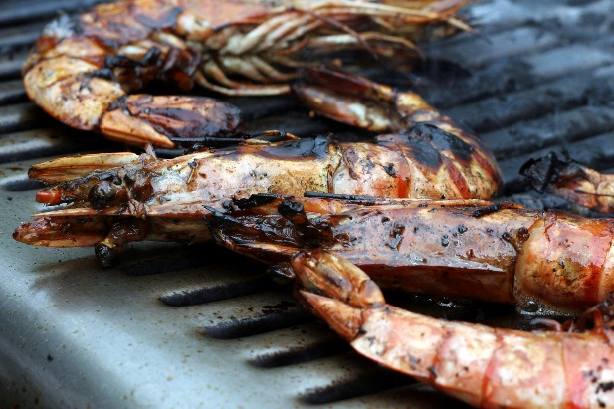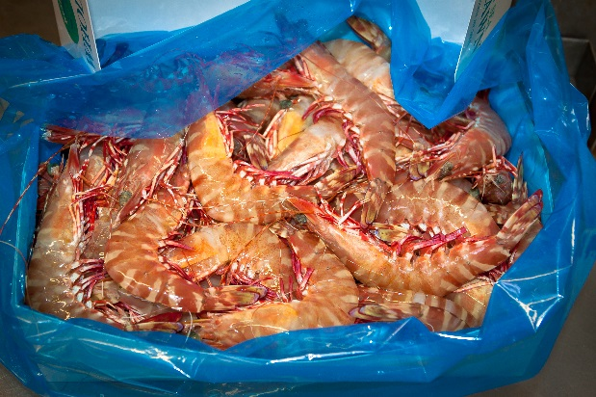

### Fishing catch rates and stock biomass

Figures 5 and 6 show the trends in “catch rates” (CPUE) for tiger prawn and endeavour prawn. This is measured as the average kilograms of catch per boat day of fishing (kg/d). The small percentage (3-10%) of daily vessel records that are flagged as representing a partial day of fishing (hours trawled < 9) are excluded from the estimates of CPUE.

CPUE is an indication of the numbers of prawns on the seabed. High CPUE often indicate a large prawn biomass while low CPUE often indicate a small prawn biomass, however there are other factors that can impact on the CPUE of an individual vessel in addition to prawn abundance. These factors are; vessel size, engine power, type of nets, time of the year, moon phase, area within the fishery, fisher experience etc. The standardised CPUE used in the stock assessment models are slightly different to those presented in this data summary because they are adjusted for the factors that can affect individual vessel catch rates. This ensures that the catch rates can more accurately reflect the stock size or biomass of prawns on the seabed.

As a result the rectangles for the years 1991-2003 are wider due to the higher level of fishing effort.

**Figure 5** Yearly tiger prawn catch rates (CPUE) as kilograms per vessel per day fished (kg/d). This is calculated as the mean across all active vessels. The boxplots show the median (indicated by notch and line in box plot) and range CPUE for each year across all boats. Fifty percent of the records are within the rectangles. The “whiskers or dotted lines” extending from the rectangles show the overall range. The width of the rectangles indicates the number of records for each season. As a result the rectangles for the years 1991-2003 are wider due to the higher level of fishing effort. The trends in the means are shown by the blue (1989-1999) and green (2000-2013) trend lines.

During the 1989-1999 fishing seasons, tiger prawn CPUE (Figure 5) was variable but there is no overall upward or downward trend in the CPUE data as indicated by the dotted blue trend line for the year’s 1989 to1999 in Figure 5. This indicates that the tiger prawn stock was relatively stable until 1999. The trend line for the years 2000-2013 indicates an increase in the stock size until 2013. The tiger prawn stock assessment conducted in 2004 indicates that the increasing CPUE was the combined result of fishers becoming more efficient at catching tiger prawns and an increasing tiger prawn stock biomass.

Although the endeavour prawn CPUE data up to 2009 oscillated around 100 kg/d there was no overall upward or downward trend in the CPUE data as indicated by the dotted blue trend line for the year’s 1989 to 2009 in Figure 6. This indicates that the endeavour prawn stock size was relatively stable until 2009. Since 2010-11 which was the end of the large decline in fishing effort (Figure 3), endeavour prawn CPUE has been around 50 kg/day (Figure 6).

**Figure 6** Yearly endeavour prawn catch rates (CPUE) as kilograms per vessel per day fished (kg/d). This is calculated as the mean across all active vessels. The boxplots show the median (indicated by notch and line in box plot) and range CPUE for each year across all boats. Fifty percent of the records are within the rectangles. The “whiskers or dotted lines” extending from the rectangles show the overall range. The width of the rectangles indicates the number of records for each season. As a result the rectangles for the years 1991-2003 are wider due to the higher level of fishing effort. The trends in the mean for 1989-1999 are shown by the blue trend line.

The increase in tiger prawn CPUE since 2000 is most likely due to the combined effect of fishers targeting tiger prawn in preference to endeavour prawn and the higher abundance of tiger prawn due to the decrease in fishing effort. This is supported by stock assessment results which indicate that the tiger prawn biomass was increasing during 2001-06, was at a higher level than during the 1990s and was above Bmsy (The biomass that supports Maximum Sustainable Yield (MSY)).

During the years 2010-14 fishing effort was approximately a quarter of the Emsy based TAE of 9,200 days and the average effort for the years 1991-2001. The tiger prawn harvest was around 50% of the high effort years (1991-01) and the estimate of Maximum Sustainable Yield (MSY). Tiger prawn catch rates (CPUE) since 2010, however, were the highest recorded since 1989 (Figure 5). These high CPUEs combined with the lower harvest of tiger prawns in recent years suggests that the tiger prawn stock is still well above the Biomass associated with MSY (Bmsy), which is used as a sustainability reference point.

Due to the very low level of effort in the fishery and fishers targeting the higher value tiger prawn, the monthly CPUE of endeavour prawns can be easily biased by which vessels are fishing and where they are fishing; therefore the current CPUE indices for endeavour prawn are a poor index of the stock biomass. The below average endeavour prawn catch rates since 2009 (Figure 6) most likely reflect fishers focusing on the higher value tiger prawns. Since 2001 the endeavour prawn catch has dropped to approximately 10% of historic levels and the estimate of MSY (Table 1). Therefore the impact of fishing (fishing mortality) on the endeavour prawn stock has been quite low compared with the 1990s, when fishing mortality was much higher due to fishers targeting endeavour prawns, more vessels and much higher fishing effort. This species is more resilient to high fishing effort than tiger prawns and in the early years of this fishery the endeavour prawn stock appeared to increase with increased fishing effort.

### Spatial distribution of fishing effort and catches

The spatial distribution of fishing effort and catches, summarised to the 6 minute grid level are presented for the 2005, 2016 and 2017 fishing seasons in Figure 7 and Figure 8. To abide with logbook confidentiality requirements the data for grids where less than five vessels fished during the season are not shown. Because the Fisheries Jurisdiction Line passes through the lower sections of some grids along the border region the catch of these grids ‘appear’ to be in PNG waters as the grid centre is north of the line. Catches in grids that are within the East of Warrior closure occurred during August to November when this area is open to fishing.

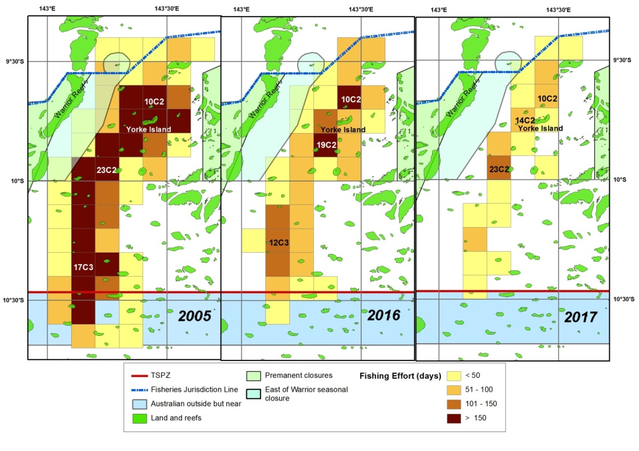**Figure 7.** Effort distribution (fishing days across all boats) within the TSPF for the 2005, 2016 and 2017 fishing seasons by 6-minute grid.

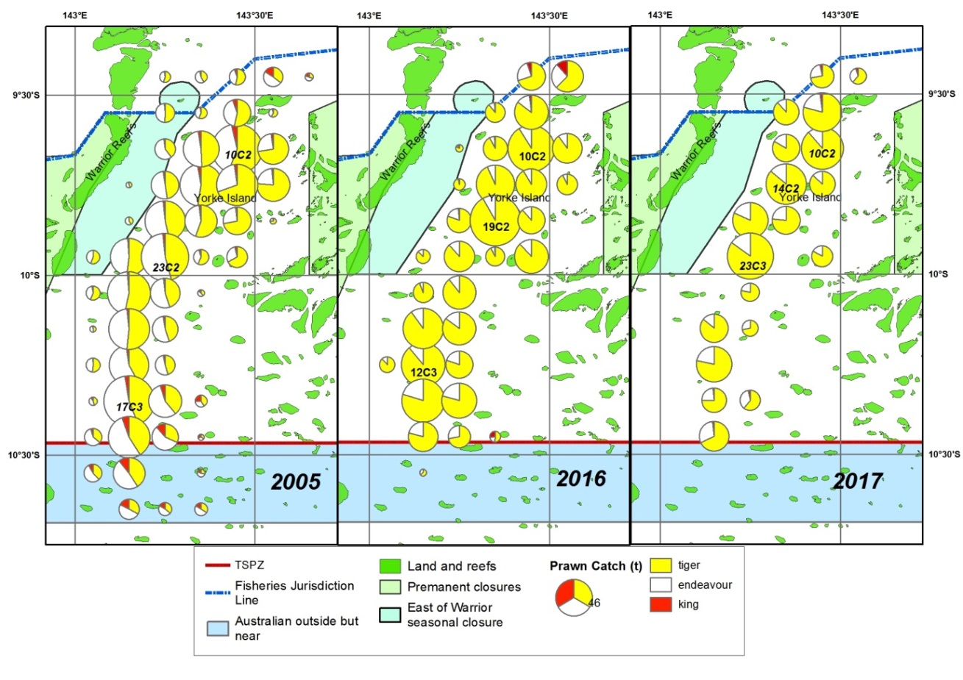**Figure 8.** Spatial distribution of catch for tiger, endeavour and king prawns during the 2005, 2016 and 2017 fishing seasons. The diameters of the pie charts are scaled by the total prawn catch for each grid.

The 2005 fishing season was chosen as a base year for comparison with the two most recent fishing seasons, because in November 2005 there was a pro rata effort reduction for the fishery to a 9,200 day cap. Also, the 2005 fishing effort (5,966 days) was approximately 60% of the years of highest effort (1991-2001) and the 2005 tiger prawn catch (651t) was just below the 1991-01 average (659t) and the estimate of MSY (676t). There were 16 grids where fishing effort was above 150 days during the 2005 fishing season (Figure 7). The grid with the highest effort and catch in 2005 was 17C3 where 408 days of effort from 53 vessels produced 39t of tiger prawn, 48t of endeavour prawn and 2.3t of king prawn. The grids next highest in fishing effort were 10C2 and 23C2 with 364 and 350 days fished resulting in 48t and 35t of tiger prawn harvest.

The grids with the highest fishing effort in 2016 were 19C2 (210 days), followed by 10C3 (169 days) and 12C3 (137 days). These grids produced 38t, 29t and 25t of tiger prawn catch. In 2017 the grids with the highest fishing effort were 23C2 (105 days), 10C2 (86 days) and 14C2 (83 days). These grids produced 13t, 11t and 10t of tiger prawn catch.

Although the 2005 pie graphs indicates that the proportion of endeavour prawn was slightly higher in the southern half of the fishery (Figure 8), the pie graphs for 2016 and 2017 shows that the reduction in the proportion of endeavour prawn in catches after 2005 occurred over the whole fishery.

### Monthly trends in Fishing Effort

Figure 9 compares the monthly fishing effort for the last two seasons (2016 and 2017) with the previous years of full logbook data (1989 to 2015). The highest levels of fishing effort (top end of the whiskers on the boxplots) were recorded during the 1990s, whereas the lowest fishing efforts were recorded in recent years.

During the years 1989-2015 fishing effort was generally highest at the start of the season (March), decreased until June, was level until September then decreased until the end of the season (Figure 9). In contrast, fishing effort in 2016 was flat across the entire fishing season and much lower than the average for the earlier years. The 2017 fishing effort was highest at the end of the season and the rest of the season was the lowest recorded.

**Figure 9.** Fishing effort as number of logbook days recorded each month for the years 2016 and 2017 and the average for 1989-2015. This is calculated as the mean across all active boats for each year. The boxplots show the median (indicated by notch and line in box plot) and range of fishing effort for each month across all boats. Fifty percent of the records are within the rectangles. The whiskers extending from the rectangles show the maximum and minimum effort that occurred each month. The logbook and VMS days are shown for 2017 and the average logbook days are shown for 2016 and for the average effort for 1989-2015. See appendix 1 for summary of monthly values from 1989-2017.

### Monthly trends in CPUE

Figures 10 and 11 compare the monthly tiger and endeavour prawn catch rates for the last two seasons (2016 and 2017) with the previous years of full logbook data (1989 to 2015).

**Figure 10.** The mean (across all active vessels) monthly tiger prawn CPUE as kilograms per boat day (kg/d) for the years 2016 and 2017 and average for the years 1989-2015. The boxplots show the variation in CPUE for each month over the years 1989 to 2015. The boxplots show the median (indicated by notch and line in box plot) and range CPUE for each month across all boats. Fifty percent of the records are within the rectangles. The “whiskers or dotted lines” extending from the rectangles show the overall range. The green line and asterisk plots the average or mean monthly CPUE for the years 1989 to 2015. See appendix 1 for summary of monthly values from 1989-2017.

The mean (average) monthly tiger prawn CPUE for the years 1989-2015 was highest at the start of the season (March) and steadily decreased to its lowest level at the end of the season (Figure 10). However, individual years have varied from the average trend and in recent years the highest CPUEs have often been in April or May. The highest CPUEs recorded in each month were all recorded in recent years and the lowest were recorded in the 1990s.

Although March 2017 tiger prawn CPUE (109 kg/d) was close to the mean for all previous years (1989-2015) it was much lower than in March of recent years; 2016 (166 kg/d), 2015 (265 kg/d), 2014 (176 kg/d) and 2013 (252 kg/d). This along with a lower total prawn CPUE of 152 kg/d compared to the 1991-2001 average of 191 kg/d and 214 kg/d for the last 5 years (Table 1) may have discouraged fishers from operating in the fishery. If fishing effort had been higher during February to April of 2017 than actually occurred, it is possible that CPUEs would have been lower than those observed in 2017 due to “a fish down” of the tiger prawn stock on the fishing grounds.

A comparison of the 2016 and 2017 monthly tiger prawn CPUE (Figure 10) indicates a poor recruitment of tiger prawns during the first few months of the 2017 fishing season. This is generally when tiger prawn recruitment is strongest as illustrated by the 2016 monthly tiger prawn CPUE which shows a rapid increase from February to April. This increase in CPUE while fishing is in progress, could only occur if more tiger prawn stock is migrating from the juvenile closure areas (West of Warrior Reef and the East of Warrior closure) into the area open to trawling at the start of the season.

**Figure 11.** The mean (average) monthly endeavour prawn CPUE as kilograms per boat day (kg/d) for the years 2016, 2017 and the mean for the years 1989 - 2015. The boxplots show the variation in CPUE for each month over the years 1989 to 2015. The boxplots show the median (indicated by notch and line in box plot) and range CPUE for each month across all boats. Fifty percent of the records are within the rectangles. The “whiskers or dotted lines” extending from the rectangles show the overall range. The green line and asterisk plots the average or mean monthly CPUE for the years 1989 to 2015. See appendix 1 for summary of monthly values from 1989-2017.

The mean monthly endeavour prawn CPUE (Figure 11) for the years 1989-2015 was highest in March-April, decreased until June when it levelled out and then decreased from September to the end of the season. The highest monthly endeavour prawn CPUEs occurred during the 1990s when fishing effort was highest and the lowest have occurred in recent years when fishing effort has been lowest. The monthly endeavour prawn CPUEs for February to June of the last two seasons (2016 and 2017) are much lower than for the means for all other years (1989-2015), whereas the trend in CPUEs for July to November follows the trend for all other years, but at a lower level. It is interesting to note that the highest monthly endeavour prawn CPUEs for the last two seasons occurred in the second half of the season.

### Summary

1. The 2017 fishing season had the lowest catch of tiger and endeavour prawns and the lowest fishing effort since 1978 when catch records commenced for this fishery.
2. The low fishing effort appears to be a result of low tiger prawn CPUE during the early months of the 2017 fishing season. The tiger prawn CPUE was still higher than during the 1990’s but was low compared with recent years and may have discouraged fishers from operating in the fishery.
3. A comparison of the 2016 and 2017 monthly tiger prawn CPUE indicates a poor recruitment of tiger prawns during the first few months of the 2017 fishing season.
4. This is generally when tiger prawn recruitment is strongest as illustrated by the 2016 tiger prawn CPUE which shows a rapid increase from February to April.

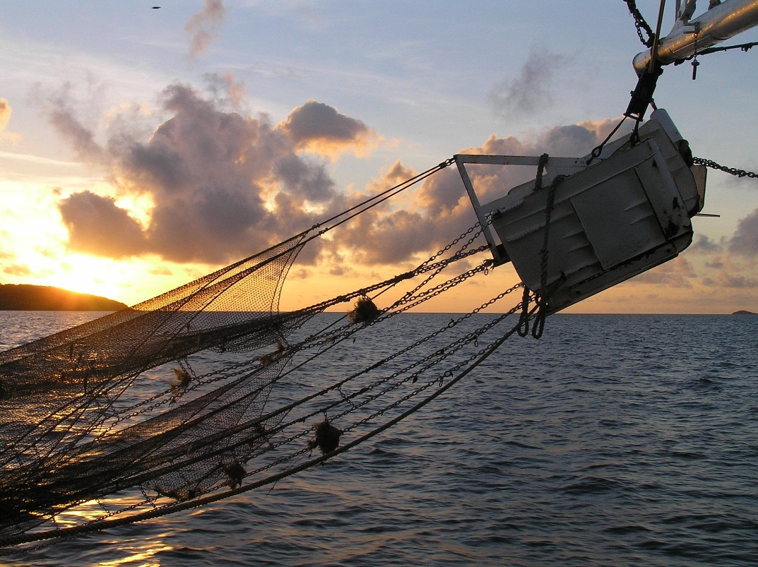

### Appendix 1 - Details by month of catches and effort since 1989

The tables below provide a summary of catch and effort for each month of each year since 1989.

*Note: Only the southern section of Torres Strait was open during March of 1989 so this data was neither presented nor used to calculate the averages displayed in the previous monthly figures.*

Table 1. Tiger prawn catch in tonnes by month for the years 1989 to 2017.

|  |  |  |  |  |  |  |  |  |  |  |
| --- | --- | --- | --- | --- | --- | --- | --- | --- | --- | --- |
| year | Feb | Mar | Apr | May | Jun | Jul | Aug | Sep | Oct | Nov |
| 1989 |  | 13 | 169 | 126 | 64 | 60 | 43 | 30 | 25 | 9 |
| 1990 |  |  | 99 | 76 | 41 | 66 | 46 | 34 | 22 | 11 |
| 1991 |  | 217 | 67 | 117 | 110 | 56 | 42 | 48 | 31 | 20 |
| 1992 |  | 245 | 147 | 102 | 87 | 62 | 87 | 67 | 52 | 29 |
| 1993 |  | 90 | 87 | 64 | 40 | 51 | 72 | 37 | 30 | 16 |
| 1994 |  | 124 | 87 | 64 | 51 | 42 | 41 | 26 | 20 | 10 |
| 1995 |  | 187 | 120 | 107 | 73 | 53 | 45 | 36 | 20 | 9 |
| 1996 |  | 246 | 90 | 68 | 71 | 58 | 57 | 40 | 29 | 10 |
| 1997 |  | 172 | 109 | 92 | 59 | 53 | 74 | 69 | 43 | 23 |
| 1998 |  | 261 | 185 | 117 | 108 | 99 | 77 | 60 | 43 | 15 |
| 1999 |  | 129 | 89 | 96 | 74 | 76 | 62 | 49 | 35 | 18 |
| 2000 |  | 121 | 74 | 52 | 61 | 59 | 42 | 36 | 23 | 10 |
| 2001 |  | 132 | 124 | 88 | 75 | 64 | 56 | 48 | 24 | 10 |
| 2002 |  | 195 | 141 | 111 | 57 | 46 | 54 | 48 | 44 | 24 |
| 2003 |  | 177 | 134 | 79 | 61 | 77 | 74 | 54 | 36 | 20 |
| 2004 |  | 124 | 91 | 50 | 33 | 37 | 41 | 31 | 14 | 8 |
| 2005 |  | 194 | 165 | 95 | 51 | 31 | 36 | 44 | 28 | 10 |
| 2006 |  | 191 | 116 | 79 | 45 | 45 | 49 | 38 | 28 | 11 |
| 2007 |  | 116 | 126 | 111 | 57 | 40 | 46 | 40 | 31 | 12 |
| 2008 |  | 87 | 81 | 71 | 37 | 51 | 46 | 30 | 24 | 13 |
| 2009 |  | 81 | 51 | 44 | 45 | 28 | 28 | 30 | 25 | 7 |
| 2010 |  | 63 | 43 | 32 | 31 | 31 | 58 | 52 | 23 | 11 |
| 2011 |  | 39 | 16 | 21 | 28 | 32 | 38 | 20 | 7 | 3 |
| 2012 |  | 84 | 69 | 71 | 54 | 52 | 32 | 14 | 15 | 9 |
| 2013 |  | 99 | 56 | 60 | 47 | 49 | 35 | 30 | 27 | 15 |
| 2014 |  | 65 | 33 | 36 | 32 | 31 | 24 | 39 | 36 | 18 |
| 2015 |  | 88 | 82 | 95 | 63 | 51 | 72 | 52 | 39 | 14 |
| 2016 | 21 | 37 | 56 | 58 | 46 | 40 | 39 | 35 | 27 | 7 |
| 2017 | 7 | 8 | 4 | 10 | 7 | 6 | 12 | 23 | 24 | 10 |

Table 2. Endeavour prawn catch in tonnes by month for the years 1989 to 2017.

|  |  |  |  |  |  |  |  |  |  |  |
| --- | --- | --- | --- | --- | --- | --- | --- | --- | --- | --- |
| Year | Feb | Mar | Apr | May | Jun | Jul | Aug | Sep | Oct | Nov |
| 1989 |  | 32 | 135 | 125 | 70 | 73 | 59 | 55 | 48 | 15 |
| 1990 |  |  | 64 | 67 | 35 | 57 | 65 | 69 | 54 | 24 |
| 1991 |  | 293 | 81 | 172 | 136 | 86 | 73 | 125 | 70 | 43 |
| 1992 |  | 222 | 160 | 119 | 104 | 79 | 121 | 124 | 104 | 67 |
| 1993 |  | 172 | 148 | 99 | 57 | 69 | 123 | 93 | 82 | 42 |
| 1994 |  | 202 | 215 | 146 | 112 | 86 | 102 | 78 | 50 | 21 |
| 1995 |  | 279 | 222 | 189 | 131 | 105 | 92 | 97 | 45 | 19 |
| 1996 |  | 241 | 141 | 98 | 78 | 82 | 97 | 85 | 47 | 24 |
| 1997 |  | 236 | 189 | 149 | 92 | 76 | 118 | 111 | 67 | 26 |
| 1998 |  | 190 | 164 | 130 | 120 | 134 | 110 | 90 | 85 | 27 |
| 1999 |  | 263 | 308 | 239 | 189 | 151 | 133 | 113 | 79 | 33 |
| 2000 |  | 278 | 200 | 136 | 101 | 102 | 88 | 95 | 58 | 19 |
| 2001 |  | 287 | 226 | 177 | 89 | 82 | 73 | 91 | 47 | 19 |
| 2002 |  | 225 | 174 | 109 | 67 | 48 | 62 | 76 | 68 | 33 |
| 2003 |  | 165 | 163 | 89 | 48 | 59 | 78 | 75 | 52 | 29 |
| 2004 |  | 104 | 114 | 68 | 34 | 39 | 54 | 47 | 22 | 9 |
| 2005 |  | 117 | 124 | 100 | 54 | 31 | 44 | 66 | 47 | 14 |
| 2006 |  | 186 | 177 | 95 | 51 | 41 | 40 | 41 | 32 | 7 |
| 2007 |  | 124 | 113 | 87 | 42 | 30 | 36 | 36 | 27 | 6 |
| 2008 |  | 87 | 93 | 71 | 34 | 34 | 42 | 33 | 19 | 6 |
| 2009 |  | 43 | 31 | 22 | 24 | 13 | 14 | 16 | 8 | 2 |
| 2010 |  | 20 | 14 | 10 | 7 | 9 | 23 | 20 | 6 | 1 |
| 2011 |  | 10 | 6 | 7 | 9 | 14 | 14 | 8 | 3 | 1 |
| 2012 |  | 15 | 21 | 23 | 18 | 17 | 12 | 5 | 3 | 2 |
| 2013 |  | 32 | 12 | 11 | 8 | 12 | 13 | 9 | 5 | 1 |
| 2014 |  | 14 | 7 | 6 | 8 | 8 | 8 | 13 | 9 | 3 |
| 2015 |  | 26 | 21 | 19 | 15 | 14 | 30 | 22 | 15 | 4 |
| 2016 | 2 | 4 | 4 | 3 | 5 | 9 | 12 | 13 | 4 | 1 |
| 2017 | 0 | 1 | 0 | 1 | 1 | 1 | 4 | 8 | 7 | 1 |

Table 3. King prawn catch in tonnes by month for the years 1989 to 2017.

|  |  |  |  |  |  |  |  |  |  |  |
| --- | --- | --- | --- | --- | --- | --- | --- | --- | --- | --- |
| Year | Feb | Mar | Apr | May | Jun | Jul | Aug | Sep | Oct | Nov |
| 1989 |  | 3.3 | 5.7 | 6.2 | 3.2 | 1.7 | 1.4 | 1.5 | 1.7 | 0.6 |
| 1990 |  |  | 5.3 | 6.6 | 2.7 | 3.2 | 2.0 | 1.5 | 0.8 | 1.5 |
| 1991 |  | 30.0 | 5.5 | 8.8 | 5.9 | 4.4 | 3.3 | 4.3 | 4.6 | 3.0 |
| 1992 |  | 20.3 | 8.0 | 5.2 | 5.6 | 2.5 | 3.3 | 4.3 | 2.9 | 3.1 |
| 1993 |  | 12.0 | 7.0 | 5.4 | 2.8 | 3.5 | 4.7 | 1.3 | 1.3 | 0.6 |
| 1994 |  | 13.2 | 10.9 | 8.3 | 3.8 | 2.3 | 2.1 | 1.2 | 1.0 | 2.2 |
| 1995 |  | 9.6 | 6.3 | 6.1 | 2.8 | 2.7 | 1.2 | 1.0 | 0.8 | 0.1 |
| 1996 |  | 9.6 | 5.9 | 2.7 | 1.4 | 1.3 | 0.9 | 1.2 | 1.1 | 0.4 |
| 1997 |  | 6.3 | 7.3 | 4.4 | 3.1 | 1.5 | 2.9 | 2.6 | 3.2 | 3.4 |
| 1998 |  | 29.4 | 24.5 | 13.7 | 9.5 | 5.8 | 6.0 | 5.8 | 6.8 | 2.7 |
| 1999 |  | 19.3 | 13.2 | 6.3 | 4.1 | 3.6 | 3.0 | 3.7 | 3.9 | 3.5 |
| 2000 |  | 33.8 | 18.1 | 6.1 | 4.3 | 3.8 | 2.0 | 2.1 | 1.6 | 0.8 |
| 2001 |  | 27.3 | 14.3 | 6.2 | 2.6 | 1.3 | 1.6 | 5.4 | 9.6 | 8.5 |
| 2002 |  | 75.3 | 45.0 | 15.4 | 4.5 | 2.6 | 2.1 | 4.1 | 8.1 | 7.2 |
| 2003 |  | 48.0 | 26.0 | 15.2 | 7.2 | 5.0 | 4.3 | 5.6 | 8.4 | 6.2 |
| 2004 |  | 23.7 | 14.0 | 4.9 | 3.2 | 1.7 | 2.2 | 4.0 | 2.4 | 1.0 |
| 2005 |  | 11.8 | 13.5 | 9.8 | 4.6 | 1.4 | 2.3 | 3.5 | 3.3 | 0.8 |
| 2006 |  | 15.7 | 12.3 | 6.2 | 2.6 | 2.0 | 2.5 | 2.1 | 1.3 | 0.5 |
| 2007 |  | 18.8 | 12.1 | 6.0 | 3.2 | 2.2 | 2.2 | 1.6 | 1.7 | 1.3 |
| 2008 |  | 16.1 | 11.9 | 4.9 | 2.3 | 4.9 | 4.1 | 2.3 | 1.4 | 0.6 |
| 2009 |  | 5.2 | 3.7 | 1.8 | 2.3 | 1.2 | 0.6 | 0.7 | 0.7 | 0.1 |
| 2010 |  | 2.4 | 1.6 | 1.1 | 0.7 | 0.4 | 1.1 | 1.1 | 0.3 | 0.2 |
| 2011 |  | 0.2 | 0.2 | 0.2 | 1.0 | 1.2 | 1.0 | 0.1 | 0.1 | 0.2 |
| 2012 |  | 0.2 | 0.8 | 0.4 | 1.2 | 0.2 | 0.0 | 0.2 | 0.1 | 0.0 |
| 2013 |  | 0.2 | 0.2 | 0.5 | 0.2 | 0.3 | 0.3 | 0.4 | 0.2 | 1.3 |
| 2014 |  | 0.3 | 0.2 | 0.1 | 0.1 | 0.8 | 0.5 | 0.7 | 0.2 | 0.1 |
| 2015 |  | 0.1 | 0.3 | 0.8 | 1.4 | 0.6 | 3.0 | 0.7 | 4.1 | 5.9 |
| 2016 | 1.1 | 0.4 | 0.7 | 0.2 | 0.2 | 0.2 | 0.9 | 0.8 | 0.8 | 0.2 |
| 2017 | 0.0 | 0.1 |  | 0.0 | 0.0 | 0.0 | 0.0 | 0.1 | 0.4 | 0.2 |

Table 4. Number of days recorded as fished in Torres Strait by the fleet by month for the years 1989 to 2017.

|  |  |  |  |  |  |  |  |  |  |  |
| --- | --- | --- | --- | --- | --- | --- | --- | --- | --- | --- |
| year | Feb | Mar | Apr | May | Jun | Jul | Aug | Sep | Oct | Nov |
| 1989 |  | 184 | 1367 | 1605 | 1056 | 1063 | 809 | 742 | 666 | 280 |
| 1990 |  |  | 906 | 1004 | 507 | 864 | 809 | 724 | 543 | 318 |
| 1991 |  | 2427 | 596 | 1228 | 1531 | 1030 | 733 | 1039 | 853 | 531 |
| 1992 |  | 2217 | 1453 | 1377 | 1357 | 1083 | 1208 | 1166 | 1182 | 854 |
| 1993 |  | 1115 | 1075 | 1015 | 645 | 794 | 1440 | 948 | 931 | 554 |
| 1994 |  | 1570 | 1493 | 1160 | 956 | 921 | 1161 | 887 | 734 | 361 |
| 1995 |  | 1610 | 1249 | 1147 | 969 | 867 | 840 | 763 | 488 | 221 |
| 1996 |  | 1709 | 1080 | 882 | 877 | 917 | 1077 | 833 | 736 | 340 |
| 1997 |  | 1671 | 1487 | 1306 | 1092 | 853 | 1209 | 1157 | 853 | 467 |
| 1998 |  | 1693 | 1369 | 1125 | 1098 | 1176 | 1104 | 1050 | 1028 | 475 |
| 1999 |  | 1383 | 1332 | 1477 | 1504 | 1331 | 1249 | 1142 | 961 | 501 |
| 2000 |  | 1889 | 1504 | 1100 | 1058 | 1153 | 931 | 1094 | 835 | 397 |
| 2001 |  | 1821 | 1562 | 1364 | 1203 | 1058 | 1055 | 1082 | 697 | 282 |
| 2002 |  | 1914 | 1503 | 1438 | 863 | 713 | 849 | 970 | 903 | 463 |
| 2003 |  | 1797 | 1573 | 1066 | 619 | 763 | 928 | 1004 | 794 | 447 |
| 2004 |  | 1010 | 949 | 560 | 374 | 456 | 617 | 556 | 293 | 122 |
| 2005 |  | 1124 | 1182 | 912 | 603 | 386 | 451 | 615 | 549 | 185 |
| 2006 |  | 1144 | 877 | 578 | 358 | 315 | 356 | 360 | 304 | 110 |
| 2007 |  | 1021 | 871 | 703 | 431 | 342 | 425 | 431 | 409 | 183 |
| 2008 |  | 534 | 535 | 531 | 341 | 369 | 413 | 297 | 285 | 170 |
| 2009 |  | 436 | 298 | 237 | 284 | 192 | 194 | 199 | 202 | 59 |
| 2010 |  | 321 | 222 | 172 | 149 | 153 | 307 | 309 | 163 | 82 |
| 2011 |  | 199 | 93 | 112 | 167 | 204 | 253 | 170 | 67 | 40 |
| 2012 |  | 364 | 276 | 335 | 275 | 294 | 220 | 116 | 122 | 78 |
| 2013 |  | 407 | 221 | 245 | 185 | 238 | 185 | 197 | 181 | 127 |
| 2014 |  | 371 | 166 | 193 | 194 | 203 | 165 | 254 | 256 | 149 |
| 2015 |  | 334 | 357 | 445 | 323 | 271 | 434 | 356 | 320 | 153 |
| 2016 | 212 | 225 | 288 | 313 | 244 | 216 | 251 | 257 | 242 | 72 |
| 2017 | 72 | 74 | 30 | 76 | 56 | 38 | 83 | 177 | 225 | 104 |

