Explanatory Statement

Torres Strait Finfish Fishery Management Plan 2013

Issued by the authority of the Protected Zone Joint Authority

Torres Strait Fisheries Act 1984
Section 15A of the Torres Strait Fisheries Act 1984 (the Act) provides for the Minister to determine written plans of management for each fishery that it manages. Subsection 35(1) of the Act provides that the powers of the Minister under sections 14, 15A, 16 and 17 of the Act are exercisable by the Protected Zone Joint Authority (PZJA). The PZJA intends on determining the Torres Strait Finfish Fishery Management Plan 2013 (the Plan) prior to the commencement of the 2013 fishing season.

The Torres Strait Finfish Fishery
The Act establishes the Torres Strait Protected Zone Joint Authority (PZJA) to manage the Torres Strait fisheries on behalf of the Commonwealth and Queensland and in accordance with the Torres Strait Treaty 1985 with Papua New Guinea.
Its members comprise the Commonwealth and Queensland Ministers responsible for fisheries, and the Chair of the Torres Strait Regional Authority (TSRA). The Commonwealth Minister is the Chair of the PZJA.
The PZJA is responsible for monitoring the condition of the designated fisheries and for the formulation of policies and plans for their management through support from four government agencies; the Australian Fisheries Management Authority, the Queensland Department of Employment, Economic Development and Innovation, the Department of Agriculture Fisheries and Forestry, and the Torres Strait Regional Authority. In exercising its functions, the PZJA has regard to the rights and obligations conferred on Australia by the Torres Strait Treaty, in particular the protection of the traditional way of life and livelihood of the Traditional Inhabitants, including the capacity to engage in traditional fishing.
The Act provides for the Torres Strait Fisheries to be managed under the laws of the Commonwealth or Queensland. In October 1996 the PZJA agreed that all commercial fishing activity in the Torres Strait would be managed under the laws of the Commonwealth.

Description of the fishery
The Torres Strait Finfish Fishery (TSFF; Figure 1) is a multi-species fishery targeting a range of reef fish and Mackerel species. The Reef Line fishery focuses primarily on the high value Coral Trout species (Plectropomus spp. and Variola spp.), Barramundi Cod (Cromileptes altivelis), mixed reef fish (Lutjanus spp. and Lethrinus spp.), and numerous species of Rock Cod (Epinephelus spp.). Up to 100 species of fish may be taken and sold as “reef fish”. The Mackerel fishery primarily targets the Narrow-barred Spanish Mackerel (Scomberomorus commerson), but may also take School Mackerel (Scomberomorus queenslandicus), Grey Mackerel (Scomberomorus semifasciatus), Spotted Mackerel (Scomberomorus munroi), and Shark Mackerel (Grammatorcynus bicarinatus).
Reef fish are generally taken by handlines rigged with a single hook and sinker and Spanish Mackerel are fished by trolling. Fishing generally occurs from either a primary or tender boat.
The fishery is limited to the Traditional Inhabitant sector; however non-Traditional Inhabitant fishers can lease a temporary (sunset) licence to fish in the fishery.
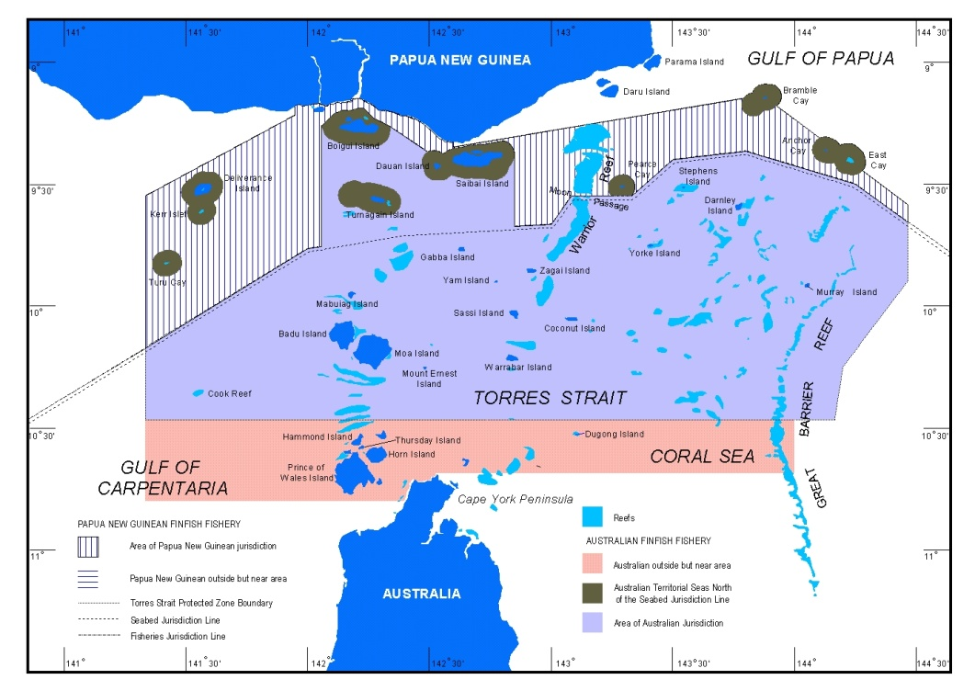

Figure 1: Area of the Torres Strait Finfish Fishery

The Torres Strait Finfish Fishery Management Plan

Consultation
While there is no requirement under the Act to conduct consultation in relation to PZJA managed fisheries, the management philosophy of the PZJA involves a partnership approach to the management of marine resources under its jurisdiction. In addition, the Legislative Instruments Act 2003 requires that consultation on that instrument must be undertaken before it is made. As a result, the draft Plan has been developed in close consultation with the Torres Strait Finfish Working Group over six meetings since October 2006 as well as the Torres Strait Fisheries Management Advisory Committee (TSFMAC), an advisory committee made up of commercial fishery members, Traditional Inhabitants, environmental groups, research and government members.

The draft Plan will also be released for broader public consultation over a period of five weeks from 01 February to 09 March 2012 and comments received will be reviewed and included where appropriate.

The draft Plan will be endorsed by the PZJA and determined by the Minister for Agriculture, Fisheries and Forestry in accordance with s15A of the Act.

Regulation Impact Statement
The Office of Best Practice Regulation has advised the Australian Fisheries Management Authority that the implementation of the Plan will formalise some of the existing management arrangements but does not significantly change the way the fishery is managed. Therefore a Regulation Impact Statement is not required (OBPR ID 2011/12705).

Need for a management plan
There is increasing community demand and statutory requirements for all Commonwealth fisheries to be managed under an ecosystem based fisheries management regime. Developing a framework to mitigate potential threats of overfishing and to preserve the marine environment in accordance with reasonable community expectations is a key challenge facing fisheries management, including those managed by the PZJA.

Excess fishing capacity has been recognised as a major impediment to achieving sound fisheries management outcomes and has generally arisen through the lack of effective property rights. In the absence of secure and transferable access rights there are few safeguards against overcapitalisation and few market-based incentives for operators to conserve resources for the long-term.

The current Wildlife Trade Operation approval from the Department of Sustainability, Environment, Water, Population and Communities (SEWPaC), which allows operators in the fishery to export their product, was provided for the Torres Strait Finfish Fishery with recommendation that the PZJA:
- review and formalise management arrangements for the fishery; and
- develop objectives, performance indicators and performance measures for target, by-product, bycatch and protected species.

With the aim of ensuring the sustainability of this fishery into the future, PZJA decisions and SEWPaC recommendations require that the PZJA introduce formal management arrangements for the Torres Strait Finfish Fishery through a plan of management. Therefore the proposed draft plan will accommodate quota management, if required, along with other management arrangements in order to meet SEWPaC’s requirements for a Wildlife Trade Operation approved fishery.

Management under the Plan
The TSFF is currently managed under input controls which are enforced under the Act through Fisheries Management Instrument No. 8 (Prohibitions Relating to the Taking, Processing and Carrying of Finfish) and No. 79 (Prohibitions Relating to the Taking, Processing and Carrying of Spanish Mackerel). Both of these notices outline the requirements on gear, size and area restrictions and take and carry limits. Other supporting legislation that governs the management of these fisheries includes the Torres Strait Fisheries Regulations 1985 and the Torres Strait Treaty 1985.

To fish commercially in the fishery, commercial fishing licenses are required and are granted as either a Traditional Inhabitant boat (TIB) licence (available only to Traditional Inhabitants residing in the Torres Strait) or a Sunset licences (available to both Traditional Inhabitants and non-Traditional Inhabitants under lease agreements with TSRA). These licences have entries attached to them that allow a licensee to commercially fish in either the Reef Line fishery and/or the Mackerel fishery. A limited number of sunset licences are held by the TSRA that may be temporarily transferred to non-Traditional Inhabitants to enable them to participate in the fishery (as per PZJA policy) but the number of TIB licences is not currently restricted.

The draft Plan provides for the PZJA to implement a quota management system if the status of the fishery warrants introduction of an output management strategy. The draft Plan provides for the fishery resource to be unitised by determining a total number of Units of Fishing Capacity for the fishery, and issuing these units to licence holders or holding them to provide for catch sharing arrangements with Papua New Guinea.

The draft Plan provides for the PZJA to limit the number of entries to fish in the TSFF to be issued to licence holders to implement a quota management system if required. The PZJA may also allow for transfer of TIB licences if required to facilitate implementation of Individual Transferable quota allocations to Traditional Inhabitants.

The draft Plan provides for the PZJA to set a maximum number of tenders to be used in the fishery, or a maximum number of tenders per operations.

Reporting of fishing activity and catch in the fishery is compulsory for Sunset licence holders and Traditional Inhabitant fishers with boats over 7m. There are currently no Traditional Inhabitants operating boats over 7m, and therefore reporting for the entire Traditional Inhabitant sector is non-compulsory. A voluntary reporting system is however in place whereby fish buyers can report product they receive from Traditional Inhabitants fishers in a docket book.

Benefits of the new system under the Plan
When the PZJA made the decision in 2005 to change the management of the TSFF from input to output controls (a quota management system) through the implementation of a plan of management, the stocks of finfish were being harvested either at maximum levels (of Spanish Mackerel) or uncertain (reef line) and levels of effort in the fishery were uncapped. Therefore, moving to an output control management system for this fishery was considered to be the best management option by the PZJA and was in line with the Ministerial Direction under which all other Commonwealth fisheries were to be managed.

Since this time, the fishery has undergone significant change with all of the non-Traditional Inhabitant licences being removed. As the majority of the catch was taken by non-traditional inhabitant licences, the buyout resulted in a marked decrease in catch. In light of the changed status of the fishery, it was considered unnecessary to implement quota management on commencement of the Plan, however the Plan allows for quota to be introduced if required in the future. The provisions in the Plan related to quota allow for maximum flexibility such that the most appropriate quota management system can be introduced based on the status of the fishery at the time.

Details of the management plan
The basic content of each section of the Plan is explained below:

PART 1: Preliminary
Section | Details
Section 1.1 | Provides for the Plan to be cited as the Torres Strait Finfish Fishery Management Plan 2013.
Section 1.2 | Provides for the Plan to commence on the day after registration on the Federal Register of Legislative Instruments.
Section 1.3 | Prescribes the definitions of terms used in the Plan. These include ‘fishing season’, ‘mackerel’, mackerel line entry’, reef fish’, reef fish line entry’, dinghy’, tender boat’, primary boat’, total allowable catch’, total allowable effort’, ‘sunset licence’, ‘TSFF boat licence/master fisherman’s licence/non-boat licence/TPC licence’.
Section 1.4 | Prescribes what a Fisheries Offence is and when a person is taken to be under investigation.
Section 1.5 | Prescribes the area of the fishery to which the plan applies, being the Torres Strait Finfish Fishery. Schedule 1 describes the area of the fishery by reference to the Geocentric Datum of Australia 1996 (GDA96).
Section 1.6 | Prescribes the objectives of the Plan.
Section 1.7 | Prescribes the measures by which the PZJA will attain the objectives and the performance criteria and time frames for assessing achievement against the objectives (as required by Section 15A(2) of the Act)
Section 1.8 | Provides for the PZJA, acting on advice from the Torres Strait Finfish Working Group (FFWG) and the Torres Strait Fisheries Management Advisory Committee (TSFMAC), to develop reference points to ensure that the fishery is managed sustainably and the objectives of the Plan are met.
Section 1.9 | Provides that the management plan applies to persons engaged in commercial fishing for finish; or carrying, or processing and carrying, commercially caught finfish; or fishing under a scientific or developmental permit. This means in effect that the Plan applies to:  - Traditional Inhabitants holding a Traditional Inhabitant Boat (TIB) licence with an entry to fish for reef fish or Mackerel;  - Non-Traditional Inhabitants that lease a commercial fishing licence to fish in the Torres Strait Reef Line or Mackerel fisheries;  - Hold either a scientific or developmental research permit; and  - PNG fishers holding a Treaty endorsement that allows them to fish for finfish in the Australian area of jurisdiction.
Section 1.10 | Provides that the management plan does not apply to a person engaged in:  - recreational fishing for reef fish or Mackerel;  - traditional fishing.

PART 2: Fishing in the fishery
Section | Details
Section 2.1 | Prescribes that a person may commercially fish in the fishery if they hold, or are acting on behalf of a person who holds, a licence that has a reef line or Mackerel entry and is one of the following:  - A Traditional Inhabitant of the Torres Strait;  - A non-Traditional Inhabitant fisher who has leased a licence;  - A PNG fisher who is cross-endorsed to fish in the Australian area of jurisdiction;  - A person holding a scientific or developmental permit; or  - If a quota management system is implemented, a person who holds unused units of fishing capacity for the fishery.
Section 2.2 | Provides that the species of fish that can be taken commercially in the Torres Strait Finfish Fishery, by those people holding the appropriate licence and entry, will be outlined in determinations made under section 16 of the Act.
Section 2.3 | Provides that the species of fish that are prohibited to be taken commercially in the Torres Strait Finfish Fishery will be outlined in determinations made under section 16 of the Act.
Section 2.4 | Provides that the maximum and/or minimum size limits for species of fish that can be taken commercially in the Torres Strait Finfish Fishery will be outlined in determinations made under section 16 of the Act.
Section 2.5 | Provides that the rules that apply to fishing methods and the catch or incidental capture of by-catch or by-product will be set out in determinations made under section 16 of the Act.
Section 2.6 | Provides for the fishing season for the Torres Strait Finfish Fishery and sets out the provisions for determining an alternative fishing season if required.
Section 2.7 | Prescribes the requirements for the PZJA, in consultation with the Torres Strait Fisheries Management Advisory Committee, to close the fishery if a significant threat to the sustainability of the fishery exists. It further provides for the PZJA to revoke its decision to allow fishing to continue.
Section 2.8 | Provides for the PZJA to consult with the TSFMAC before making a decision under this Part. It further provides that the PZJA must publish details of the decision on the PZJA website.

PART 3: Units of Fishing Capacity
Section | Details
Section 3.1 | Provides for the PZJA to determine a Total Allowable Catch (TAC) for the fishery, including prescribing the prior consultation that must be undertaken.
Section 3.2 | Provides for the PZJA to determine that a TAC or part of a TAC is competitive if a TAC has been determined under section 3.1 of the Plan.
Section 3.3 | Provides for the PZJA to determine a Total Allowable Effort (TAE) for the fishery, including prescribing the prior consultation that must be undertaken.
Section 3.4 | Provides for the PZJA to determine that a TAE or part of a TAE is competitive if a TAE has been determined under section 3.3 of the Plan.
Section 3.5 | Provides for the PZJA to amend a TAC or TAE during a fishing season if there is evidence that the fishery is over or under fished or if there is an immediate threat to the survival of stocks.
Section 3.6 | Provides that if a determination is made under section 3.1, 3.2, 3.3, 3.4 or 3.5 of the Plan it must be published on the PZJA website and if practicable, all holders of TSFF licences must be notified.
Section 3.7 | Provides that the PZJA must determine a maximum number of units of fishing capacity and who it may allocate units to.
Section 3.8 | Provides that the PZJA must give a certificate of allocation to a person if units of fishing capacity have been allocated. It further provides the details that must be included in the allocation certificate and the circumstances in which a replacement certificate may be issued.
Section 3.9 | Prescribes the formula to be used to determine the unit value of fishing capacity if the PZJA has determined a TAC or TAE for the fishery.
Section 3.10 | Prescribes the basis on which units of fishing capacity may be permanently or temporarily transferred between individual Traditional and non-Traditional Inhabitant fishers and/or groups.

PART 4: Licences
Section | Details
Section 4.1 | Refers to the powers to grant commercial fishing licences and endorsements in sections 19 and 20 of the Torres Strait Fisheries Act 1984 respectively.
Section 4.2 | Provides that licences granted under section 19(2) of the Torres Strait Fisheries Act 1984 (the Act) allow the use of the boat nominated on the licence for commercial fishing in the fishery.  It further provides that licences granted under section 19(3) of the Act allow the boat nominated to the licence to be used for processing or carrying finfish that have been taken with another boat.
Section 4.3 | Provides that sunset licences can only be granted to a group for the purpose of the group temporarily transferring the licence to a group or individual and allows the holder to fish commercially in the fishery for a period.
Section 4.4 | Provides that a treaty endorsement may be granted to the holder of a Papua New Guinea licence (under section 20 of the Act) to commercially fish for finfish and carry or process finfish in the fishery.
Section 4.5 | Provides that a boat may be nominated to a TSFF boat licence, a TSFF TPC licence or a sunset licence (as per section 25 of the Act).
Section 4.6 | Refers to the power of the PZJA under section 21 of the Act to make entries in licences and endorsements, and to, limit the number of entries.
Section 4.7 | Prescribes that a licence holder may permanently or temporarily transfer a licence granted under section 19 of the Act to a Traditional Inhabitant or a group and prescribes requirements that need to be met in order to transfer a licence.
Section 4.8 | Prescribes requirements for operating primary and tender boats in the fishery, how they interact with each other and how they should be identified. This provision complements the requirements in the Regulations for identifying boats through the use of a distinguishing number.  It further prescribes that the PZJA, in consultation with the Torres Strait Fisheries Management Advisory Committee, can determine the maximum number of tenders for each licence and the whole fishery.
Section 4.9 | Provides that scientific or developmental permits may be granted by the PZJA as per the requirements set out in section 12 of the Act and that the PZJA may determine guidelines for the granting, revoking and variation of these licenses and/or conditions.
Section 4.10 | Provides the powers of the PZJA under the Act are not limited by Part 4 of the Plan.

PART 5 – Licence and endorsement conditions
Section | Details
Section 5.1 | Prescribes general conditions of Torres Strait Finfish licenses and treaty endorsements including the requirement to comply with the Plan and any Regulations and determinations.
Section 5.2 | Prescribes conditions and requirements of a licensed or endorsed operator to record their catch in a logbook if the PZJA determines the need to furnish information from this fishery under section 12 of the Act.
Section 5.3 | Prescribes conditions and requirements that licence or endorsement holders must comply with if the PZJA implements a quota monitoring system in the fishery.
Section 5.4 | Prescribes other obligations of licence and endorsement holders.
Section 5.5 | Prescribes conditions that licence or endorsement holders must comply with if an observer program is implemented in the fishery.
Section 5.6 | Prescribes conditions that licence or endorsement holders must comply with if a vessel monitoring system (VMS) is implemented in the fishery.
Section 5.7 | Prescribes obligations that licence and endorsement holders need to comply with in respect to interactions with certain species and communities including cetaceans (whales and dolphins), marine, migratory or threatened species.
Section 5.8 | Prescribes conditions that licence and endorsement holders must comply with in respect to the catch of by-product.
Section 5.9 | Provides that the PZJA may consult with the TSFMAC and other interested persons before making a decision under this Part and the PZJA must publish details of the decision on the PZJA website.

PART 6: Miscellaneous
Section | Details
Section 6.1 | Refers to the power of the PZJA under section 16 of the Act to determine boat lengths, and provides that before making a determination it must consult with the TSFMAC.
Section 6.2 | Prescribes the details that must be included in the register in addition to those outlined in section 10 of the Act.
Section 6.3 | Provides that a person affected by a decision may request the PZJA to reconsider a decision if the request is made within 28 days of the decision being made.
Section 6.4 | Prescribes that it is prohibited to remove the fins or liver from a shark and discard the torso into the sea.
Section 6.5 | Prescribes the transitional arrangements with respect to licences that will apply to the fishery on commencement of the Plan.

Schedules
Section | Details
Schedule 1 | Prescribes the area of the fishery.
Schedule 2 | Prescribes the area of the fishery expressed using coordinates based on WGS84 datum.

