Preliminary advection modelling of Tropical Rock Lobster (Panulirus ornatus) larvae in the North Western Coral Sea

Bec Gorton, Scott Condie, Éva Plagányi, Darren Dennis

CSIRO Oceans and Atmosphere

Summary for presentation at TRL Resource Assessment Group, December 2016

Summary
A preliminary model run has been done using CSIRO’s Connie3 (www.csiro.au/connie/), which provides an update of previous advection modelling of tropical rock lobster (TRL) Panulirus ornatus larvae in the Coral Sea. The modelling was used to test the hypothesis that larvae that originate at Yule Island, considered an important spawning location for TRL, may be advected via the Coral Sea gyre back to Torres Strait to reseed future generations. Preliminary simulations confirm that this is the case, as illustrated by the trajectory shown in Fig. 1. The specifications for the simulations shown are listed below.

Release time: 2010 11 21 - 2011 02 25
Release location: As a test, added a buffer around Yule Island and release particles uniformly within that polygon. See the attached image.​
Num Particles: Released a total of 9600 over the release period, distributed over the 96 day release period.

Dispersal Length:
Phase 1:
Dispersal Length: 120 days.
Vertical distribution: 1m at night, 24 m during the day
Phase 2:
Dispersal Length: 30 days.
Vertical distribution: 1m at night, 73 m during the day

See attached plot of the results - these are the cumulative exposure stats, which is the proportion of distinct particles that passed through each geographical cell (4 km x 4 km)​. In this example the tracking only extended to around 16°S, however this could be increased for future runs. Information on individual particle tracks can be used for various types of analysis, including the potential distribution of settlement over viable habitat.
Future work: there is considerable scope to refine, improve and extend (e.g. for different years) these results to improve understanding of TRL larval advection. However these runs are time consuming, and the TRLRAG’s input will be sought as to interest in pursuing this research further, eg via a small project.
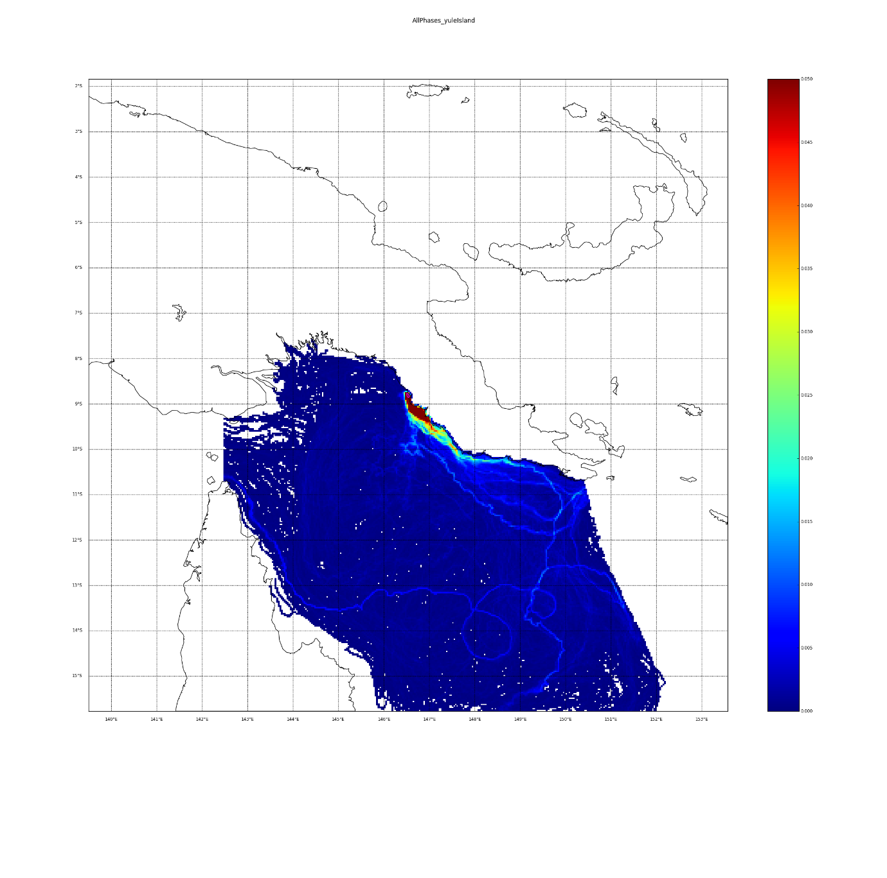
Fig. 1: Proportion of distinct particles that passed through each geographical cell (4 km x 4 km). Dark red indicates that > 5% of particles moving through a cell and the light blue paths indicate trajectories of small clusters of particles that happened not to diverge.

