Govdex quick guide

Access meeting papers through Govdex

Log in to Govdex
- In your browser go to https://govdex.gov.au/
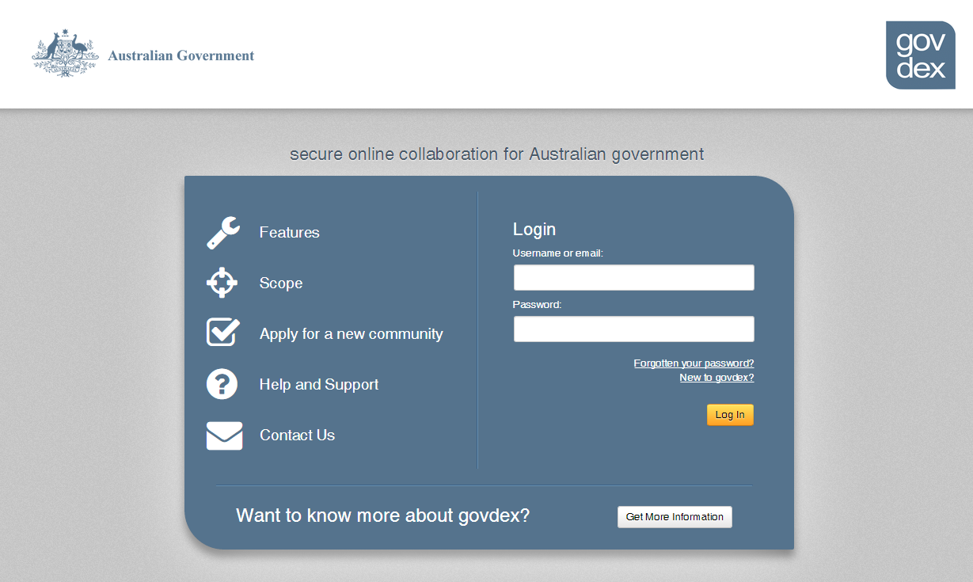
- Enter your username or email address.
- Enter your password.
- Click ‘log in’.

Access your community from the Dashboard
- The left side of the dashboard lists the Govdex Communities that you can access
- To start browsing, click on the name of the Committee (or Community) that you would like to access.
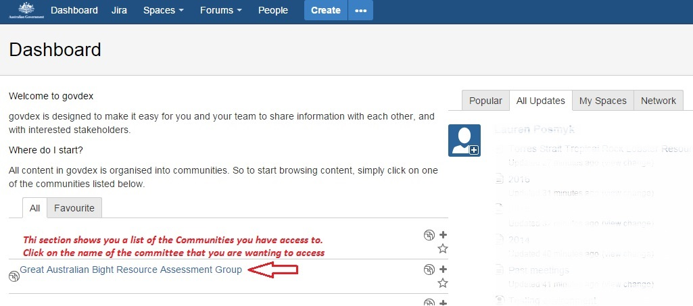

View / download meeting papers
- The left sidebar lists pages you can access
- Click on the most current meeting
- To download a paper click on the blue link text. This will open the document as a Word / PDF or Excel doc. and from there you can save it to your drive (File > Save as).
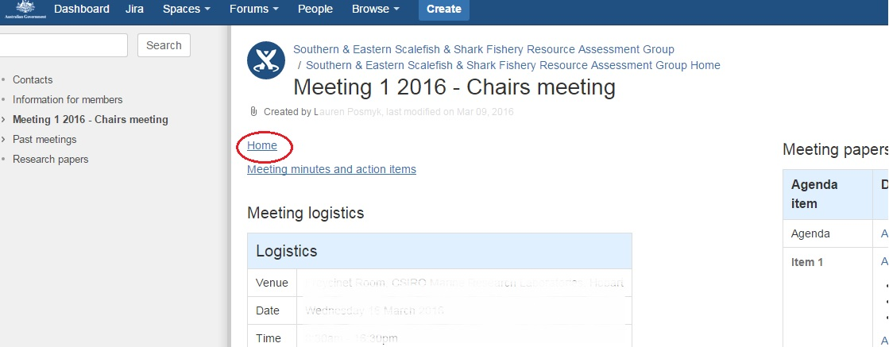

Any questions
Contact your committee Executive Officer:
Canberra office: 02 6255 5555
Thursday Island: 07 4069 1990

